QUOTATION REQUEST FORM Word Version

Please complete the form below for Drug and /or Alcohol Testing and we will get back to you very shortly with a detailed quotation based on your case. Cansford Laboratories will not disclose any information relating to tests without prior authorisation from the client.

1. Donor Detail
Donor's Name*

Date of Birth:*

Sex – Please tick or X *
Male | Female

Select Test – please tick or X
Drug and Alcohol
Drug Only
Alcohol Only

2.1. Please select the sample type(s) required for analysis:
Body hair cannot be segmented, and samples will represent an overview period based on the length of hair provided. Fingernail samples represent an approximate six-month period, toenail samples represent an approximate 12-month period. Please tick or X:

Scalp (Head) Hair
Body Hair
Nail

2.2. Please select the time period you wish to cover in months (Only applicable to scalp hair):
Months.

2.3. Please select the breakdown of testing (Only applicable to scalp hair):
Monthly
Bi-monthly
Quarterly

2.4 Select drug, medication, or steroid to be tested:

Type | Please tick X: | Type | Please tick X:
Cansford 9 Common Drug Test (Including: Amphetamine, Methamphetamines, Benzodiazepines, Cannabinoids, Cocaine, Ketamine, Methadone, Opiates, Tramadol) |  | Mephedrone
Amphetamine |  | Methadone
Antidepressants |  | Methamphetamines
Antipsychotics |  | NPS
Benzodiazepines |  | Opiates (incl. Heroin)
Buprenorphine |  | Phenibut
Cannabis |  | Propoxphene
Cathinone (Khat) |  | Pregabalin
Cocaine (incl. Crack Cocaine) |  | Propofol
Cortisol |  | Psychoactive Substances ('Legal Highs')
Gabapentin |  | Spice (Synthetic Cannabinoids)
GHB |  | Tramadol
Hallucinogens |  | Steroids
Hypnotic Sedatives |  | Zolpidem (Hypnotics)
Ketamine

3. Hair Alcohol Testing*:
*Underarm hair is not useable for alcohol testing. Pubic hair is only useable in relation to abstinence monitoring. If nail testing is requested, we are only able to test for EtG. Please tick or X:

EtG
EtG/EtPa (FAEE)

Please select the breakdown of alcohol testing
Overview
Monthly
Bi-Monthly
Quarterly

3.1. Blood Alcohol Testing:
The blood test for alcohol can be used to indicate recent excessive alcohol use. A PEth blood test measures the level of phosphatidylethanol, a direct alcohol biomarker found in human blood following alcohol consumption. Cansford use a dry blood spot (DBS) kit to collect this sample, a pinprick of blood is all that is needed. Please tick or X:

Phosphatidylethanol (PEth) Test
Carbohydrate Deficient Transferrin (CDT) Test
Liver Function (LF) Test
Full Blood Count (FBC)
A CDT test is a biochemical test that can provide biochemical evidence of recent excessive alcohol consumption. A liver function test provides a snapshot in time of liver health damage that may have come from excessive alcohol consumption. A full blood count (FBC) test looks for abnormalities in blood. CDT, LTF and FBC are all ‘wet’ blood tests, collected by direct puncture to a vein.

4. Expert Witness Report
Is an expert witness report required for presentation to court? Please tick or X.

Yes | No

5. Instructing Party Details
Please indicate who is instructing the testing:

Instructing Party Name*
Position
Address*
Telephone*
Organisation
Case Ref:
Client Name
Email*
Instructing Party Funding  Please tick or X. | Legal Aid | Publicly Funded |  | Privately Funded
Split Invoicing?  Please tick or X. | Yes |  | No

The results and Expert Witness Report are issued within 3 working days of sample receipt into our laboratory.

6. Filing Time
Please indicate if you have a set date that you are required to file the results by:

Filing Date

7.Collection Details
Please indicate who will be collecting the sample and where the sample collection needs to take place. All Cansford Collectors follow a chain of custody process. Please tick or X.
Collector
Cansford Collector
GP
Other (please provide details)

7a. Do you have a preferred Collection Date?

8. Would you kindly tell us how you heard about Cansford Labs?

What to expect from our service?
- 90% of results are returned within 48 hours of sample receipt at our laboratory.
- The ISO 17025 standard that Cansford Laboratories’ test processes meet is the most appropriate for UK drug and alcohol testing laboratories. Cansford is accredited to this standard for more substances than any other UK toxicology testing laboratory.
- Cansford’s trained collectors only require a shoelace worth of hair when taking a sample.

Returning this form
Please email your completed form to info@cansfordlabs.co.uk. Please use Quotation Request in the Subject line as follows:

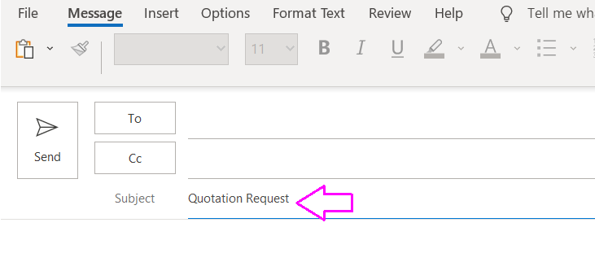

Have any questions?
Don’t hesitate to get in touch with our team
Call 029 2010 1477
Email: info@cansfordlabs.co.uk

